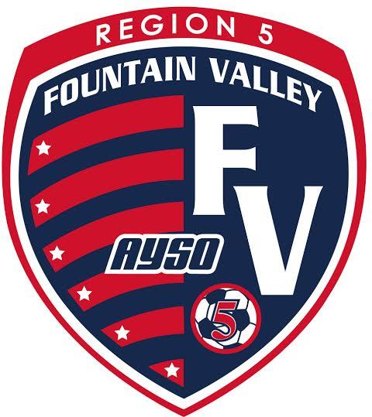
2026 HI 5 TOURNAMENT
Scope: | Holiday Invitational – open to AYSO teams from all Sections.
When: | Saturday & Sunday, January 3 and 4, 2026
Where: | The tournament will be held at the Fountain Valley Sport and Recreation Center (16400 Brookhurst Street Fountain Valley, CA 92708). Free parking at FVSP. No pets are allowed at either fields. Full Service snack bar available at FVSP.
Who: | AYSO boys and girls teams in age divisions: U-14 (11v11) U-12 (9v9) U-10 (7v7). All players must have been registered and played in their Region’s Fall 2025 season. Guest players will be allowed up to 3 maximum per team.
What: | Pool play tournament. All teams will be guaranteed 3 games with a possibility of a fourth (championship and consolation) game depending on point total. All games will be 50 minutes in length.
Why: | The HI-5 Tournament is being conducted as a fundraiser by Region 5 to raise funds for field development, equipment maintenance, maintain low registration fees, and to provide scholarship funds for youths in Region 5. It is also being used as an avenue to promote the philosophies of AYSO and to promote our region within our community.
Awards: | All players, head coach, and assistant coach from each team will receive a tournament t-shirt and pin. Players and coaches on teams placing first through fourth will receive a medal.
Entry Fee, Refunds: | $505 for U-14, $480 for U-12, and $455 for U-10. A full refund will be issued if tournament is canceled and cannot be rescheduled. If a team withdraws on or before December 20, 2024 a full refund will be issued. Following this date refunds will only be given if a replacement team is found minus a $50 administrative fee.
Referee Deposit, Refunds: | $270-fully refundable within 14 business days following the tournament, if referee assignments have been completed and no monetary deductions for infractions such as tardiness, incomplete or wrong uniform, no equipment, unqualified, etc. are assessed. Please contact Barrett Lambert at trainerbarrett@gmail.com further details. For a referee refund to be considered, each team is to provide a qualified 3-person referee team to cover 3 games during the tournament at the level of the team represented. Intermediate and above referees will be the only officials for u14 games. No refund will be given to a team who does not play all scheduled games and/or does not fulfill the referee requirement.
Rules: | A full set of tournament rules are posted at www.ayso5.org.
Acceptance: | The application deadline is December 20, 2025. All teams will be notified within 48 hours via registration website of the application deadline or receipt of application (whichever is latest) as to their status. Teams that are not accepted will be given the option to have their complete application returned or to be placed on the waiting list.
How: | Apply online at www.ayso5.org  Credit card and check payments are accepted. Contact the tournament director for details. Please send 1 Region check to cover both the Team Entry and Referee fees to the address below. Make region check payable to: AYSO Region 5 with coach name age group in the memo line.
Address: | Michael Ramirez  HI-5 Tournament  10956 la Batista Avenue  Fountain Valley, CA. 92708
Information: | Michael Ramirez  E-mail HI5tournamentdirector@gmail.com  www.ayso5.org

